Week 2 Data analytics
Task 1:-

import numpy as np
arr = np.array([10, 20, 30, 40, 50, 60, 70, 80, 90, 100])
print("Array:", arr)
print("Shape:", arr.shape)
print("Size:", arr.size)
print("Data Type:", arr.dtype)
one_d = np.array([1, 2, 3, 4, 5])
print("\nOne-Dimensional Array:")
print(one_d)
two_d = np.array([[1, 2, 3], [4, 5, 6]])
print("\nTwo-Dimensional Array:")
print(two_d)

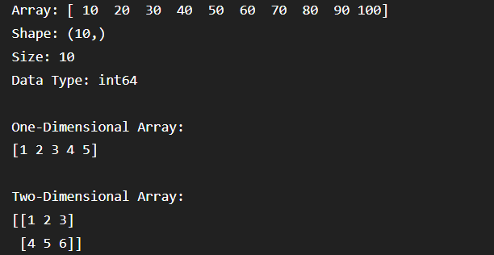

Task 2:-
import numpy as np

arr = np.array([10, 20, 30, 40, 50, 60, 70, 80, 90, 100])

print("Original Array:")
print(arr)

print("\nElement at index 0:", arr[0])
print("Element at index 4:", arr[4])
print("Element at index 7:", arr[7])

print("\nSliced Array (index 2 to 6):")
print(arr[2:7])

# Create a two-dimensional array
two_d = np.array([
[1, 2, 3],
[4, 5, 6],
[7, 8, 9]
])

print("\nTwo-Dimensional Array:")
print(two_d)

print("\nFirst Row:")
print(two_d[0])

print("\nSecond Row:")
print(two_d[1])

print("\nFirst Column:")
print(two_d[:, 0])

print("\nSecond Column:")
print(two_d[:, 1])
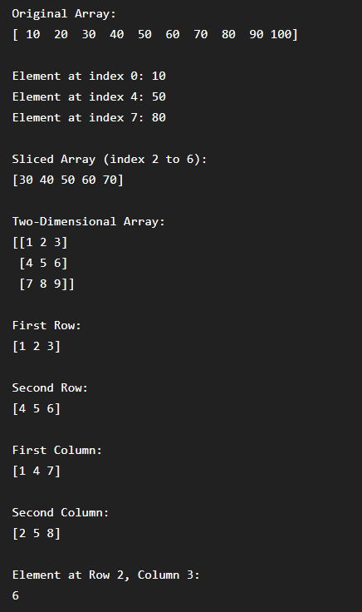
print("\nElement at Row 2, Column 3:")
print(two_d[1, 2])

reshaped = arr.reshape(2, 5)

print("\nOriginal Array:")
print(arr)

print("\nReshaped Array (2 x 5):")
print(reshaped)

Task 3:-
import numpy as np

data1 = np.array([10, 20, 30, 40, 50])
data2 = np.array([2, 4, 5, 8, 10])

print("Dataset 1:", data1)
print("Dataset 2:", data2)

print("\n--- Mathematical Operations ---")

print("Addition:", data1 + data2)

print("Subtraction:", data1 - data2)

print("Multiplication:", data1 * data2)

print("Division:", data1 / data2)

print("\n--- Statistical Functions ---")

print("Mean:", np.mean(data1))

print("Median:", np.median(data1))

print("Minimum:", np.min(data1))

print("Maximum:", np.max(data1))

print("Standard Deviation:", np.std(data1))

print("Sum:", np.sum(data1))
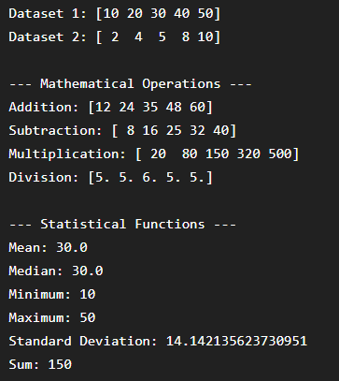

Task 4:-
import pandas as pd

marks = pd.Series([85, 90, 78, 92, 88])

print("Pandas Series:")
print(marks)

data = {
"Name": ["Aarav", "Priya", "Rahul", "Sneha", "Aman"],
"Age": [20, 21, 19, 20, 22],
"Marks": [85, 90, 78, 92, 88]
}

df = pd.DataFrame(data)
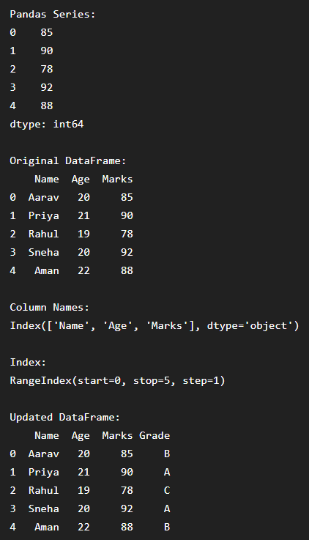

print("\nOriginal DataFrame:")
print(df)

print("\nColumn Names:")
print(df.columns)

print("\nIndex:")
print(df.index)

df["Grade"] = ["B", "A", "C", "A", "B"]
print("\nUpdated DataFrame:")
print(df)
Task 5:-
import pandas as pd

df = pd.read_csv("students.csv")

print("First 5 Rows:")
print(df.head())

print("\nLast 5 Rows:")
print(df.tail())

print("\nNumber of Rows and Columns:")
print(df.shape)
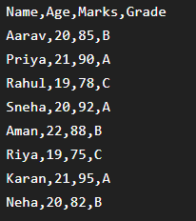

print("\nColumn Names:")
print(df.columns)

print("\nData Types:")
print(df.dtypes)

print("\nDataset Information:")
df.info()

print("\nStatistical Description:")
print(df.describe())
task 6:-
import pandas as pd

data = {
"Name": ["Aarav", "Priya", "Rahul", "Sneha", "Aman", "Riya"],
"Age": [20, 21, 19, 20, 22, 19],
"Marks": [85, 92, 68, 95, 78, 88],
"City": ["Delhi", "Mumbai", "Delhi", "Pune", "Mumbai", "Delhi"]
}
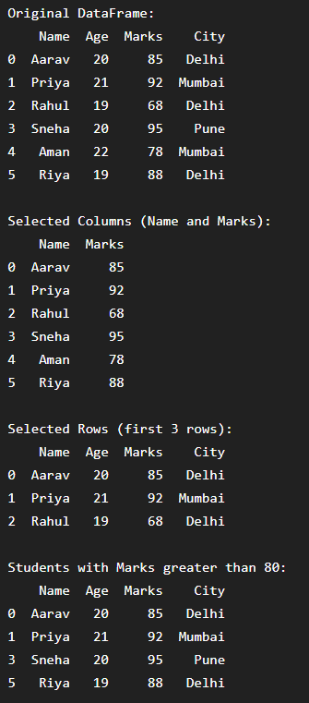

df = pd.DataFrame(data)

print("Original DataFrame:")
print(df)

print("\nSelected Columns (Name and Marks):")
print(df[["Name", "Marks"]])

print("\nSelected Rows (first 3 rows):")
print(df.iloc[0:3])

print("\nStudents with Marks greater than 80:")
print(df[df["Marks"] > 80])

print("\nStudents with Marks greater than 80 and Age less than 21:")
print(df[(df["Marks"] > 80) & (df["Age"] < 21)])

print("\nStudents sorted by Marks (Ascending):")
print(df.sort_values(by="Marks", ascending=True))

print("\nStudents sorted by Marks (Descending):")
print(df.sort_values(by="Marks", ascending=False))

Task 7:-
import pandas as pd
import numpy as np

data = {
"Name": ["Aarav", "Priya", "Rahul", "Sneha", "Aman", "Riya"],
"Age": [20, 21, np.nan, 20, 22, np.nan],
"Marks": [85, np.nan, 68, 95, np.nan, 88],
"City": ["Delhi", "Mumbai", "Delhi", np.nan, "Mumbai", "Delhi"]
}

df = pd.DataFrame(data)

print("Dataset Before Handling Missing Values:")
print(df)

print("\nMissing Values (True/False):")
print(df.isnull())

print("\nMissing Values using isna():")
print(df.isna())

print("\nCount of Missing Values in Each Column:")
print(df.isnull().sum())

df_removed = df.dropna()

print("\nDataset After Removing Rows with Missing Values:")
print(df_removed)

df_filled = df.copy()

df_filled["Age"] = df_filled["Age"].fillna(df_filled["Age"].mean())

df_filled["Marks"] = df_filled["Marks"].fillna(df_filled["Marks"].mean())

df_filled["City"] = df_filled["City"].fillna(df_filled["City"].mode()[0])

print("\nDataset After Filling Missing Values:")
print(df_filled)
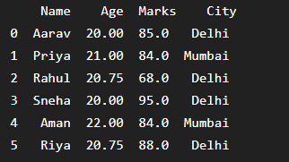

Task 8:-
import pandas as pd

students = pd.DataFrame({
"Student_ID": [101, 102, 103, 104, 105],
"Name": ["Aarav", "Priya", "Rahul", "Sneha", "Aman"],
"Department": ["IT", "CS", "IT", "CS", "IT"]
})

marks = pd.DataFrame({
"Student_ID": [101, 102, 103, 104, 105],
"Marks": [85, 92, 78, 95, 88],
"Attendance": [90, 95, 80, 92, 85]
})

print("Students DataFrame:")
print(students)

print("\nMarks DataFrame:")
print(marks)

merged_df = pd.merge(students, marks, on="Student_ID")

print("\n--- Merged DataFrame ---")
print(merged_df)

students_part1 = pd.DataFrame({
"Student_ID": [101, 102, 103],
"Name": ["Aarav", "Priya", "Rahul"],
"Marks": [85, 92, 78]
})

students_part2 = pd.DataFrame({
"Student_ID": [104, 105, 106],
"Name": ["Sneha", "Aman", "Riya"],
"Marks": [95, 88, 82]
})

concatenated_df = pd.concat(
[students_part1, students_part2],
ignore_index=True
)

print("\n--- Concatenated DataFrame ---")
print(concatenated_df)

grouped = merged_df.groupby("Department")

print("\n--- GroupBy: Mean Marks by Department ---")
print(grouped["Marks"].mean())

aggregation = merged_df.groupby("Department")["Marks"].agg(
["sum", "mean", "count", "min", "max"]
)

print("\n--- Aggregate Values by Department ---")
print(aggregation)

pivot = pd.pivot_table(
merged_df,
values="Marks",
index="Department",
columns="Name",
aggfunc="mean"
)

print("\n--- Pivot Table ---")
print(pivot)
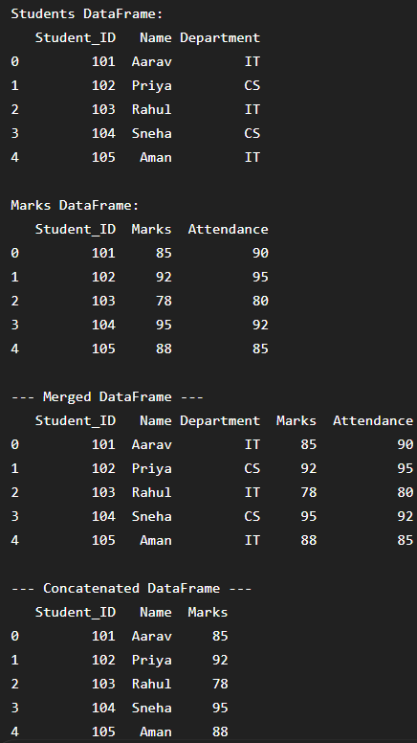

Task 10:-

import numpy as np
import pandas as pd

data = {
"Student_ID": [101, 102, 103, 104, 105, 106, 107, 108],
"Name": ["Aarav", "Priya", "Rahul", "Sneha", "Aman", "Riya", "Karan", "Neha"],
"Gender": ["Male", "Female", "Male", "Female", "Male", "Female", "Male", "Female"],
"Department": ["IT", "CS", "IT", "CS", "IT", "CS", "IT", "CS"],
"Age": [20, 21, np.nan, 20, 22, 19, 21, np.nan],
"Marks": [85, 92, 68, 95, np.nan, 88, 78, 90],
"Attendance": [90, 95, 80, 92, 85, np.nan, 88, 94]
}

df = pd.DataFrame(data)

print("Original Dataset:")
print(df)

print("\nFirst 5 Rows:")
print(df.head())

print("\nLast 5 Rows:")
print(df.tail())

print("\nShape of Dataset:")
print(df.shape)

print("\nColumn Names:")
print(df.columns)

print("\nData Types:")
print(df.dtypes)

print("\nDataset Information:")
df.info()

print("\nStatistical Summary:")
print(df.describe())

print("\nMissing Values in Each Column:")
print(df.isnull().sum())

df["Age"] = df["Age"].fillna(df["Age"].mean())

df["Marks"] = df["Marks"].fillna(df["Marks"].mean())

df["Attendance"] = df["Attendance"].fillna(df["Attendance"].mean())

print("\nDataset After Handling Missing Values:")
print(df)

print("\nMissing Values After Cleaning:")
print(df.isnull().sum())

print("\nSelected Columns - Name, Department and Marks:")
print(df[["Name", "Department", "Marks"]])

print("\nStudents Scoring 85 or More:")
print(df[df["Marks"] >= 85])

print("\nIT Students with Marks 80 or More:")
print(df[(df["Department"] == "IT") & (df["Marks"] >= 80)])

print("\nStudents Sorted by Marks - Highest to Lowest:")
sorted_df = df.sort_values(by="Marks", ascending=False)
print(sorted_df)

group_analysis = df.groupby("Department").agg(
Average_Marks=("Marks", "mean"),
Maximum_Marks=("Marks", "max"),
Minimum_Marks=("Marks", "min"),
Average_Attendance=("Attendance", "mean"),
Student_Count=("Student_ID", "count")
)

print("\nGroupBy Analysis by Department:")
print(group_analysis)

pivot_table = pd.pivot_table(
df,
values="Marks",
index="Department",
columns="Gender",
aggfunc="mean"
)

print("\nPivot Table - Average Marks by Department and Gender:")
print(pivot_table)

average_marks = df["Marks"].mean()
highest_marks = df["Marks"].max()
lowest_marks = df["Marks"].min()

top_student = df.loc[df["Marks"].idxmax(), "Name"]

department_average = df.groupby("Department")["Marks"].mean()
highest_department = department_average.idxmax()

print("\n========== USEFUL INSIGHTS ==========")

print("Overall Average Marks:", round(average_marks, 2))
print("Highest Marks:", highest_marks)
print("Lowest Marks:", lowest_marks)
print("Top Performing Student:", top_student)
print("Department with Highest Average Marks:", highest_department)

print("======================================")

output_file = "processed_student_performance.csv"

df.to_csv(output_file, index=False)

print("\nCleaned dataset exported successfully!")
print("File Name:", output_file)

verified_df = pd.read_csv(output_file)

print("\nVerified Exported Dataset:")
print(verified_df)

print("\nRows:", verified_df.shape[0])
print("Columns:", verified_df.shape[1])

print("\nMissing Values in Exported Dataset:")
print(verified_df.isnull().sum())

print("\nCSV file is ready for submission.")
